**Timer Module Verification Results**

TCL Output:

TIMER_TC_01: PASS

TIMER_TC_02: PASS

TIMER_TC_03: PASS

TIMER_TC_04: PASS

INFO: [USF-XSim-96] XSim completed. Design snapshot 'rtc_timer_tb_behav' loaded.

INFO: [USF-XSim-97] XSim simulation ran for 1000ns

launch_simulation: Time (s): cpu = 00:00:06 ; elapsed = 00:00:08 . Memory (MB): peak = 885.027 ; gain = 13.770

run 100 ms

TIMER_TC_05: PASS

TIMER_TC_06: PASS

TIMER_TC_07: PASS

TIMER_TC_08: PASS

TIMER_TC_09:

Start time: 20000250000

VERIFY TIMER_TC_09 BY OBSERVATION.

o_basetick should show a 10ms period after start time.

run: Time (s): cpu = 00:00:28 ; elapsed = 00:00:27 . Memory (MB): peak = 898.375 ; gain = 6.945

TIMER_TC_09: Verified through observation

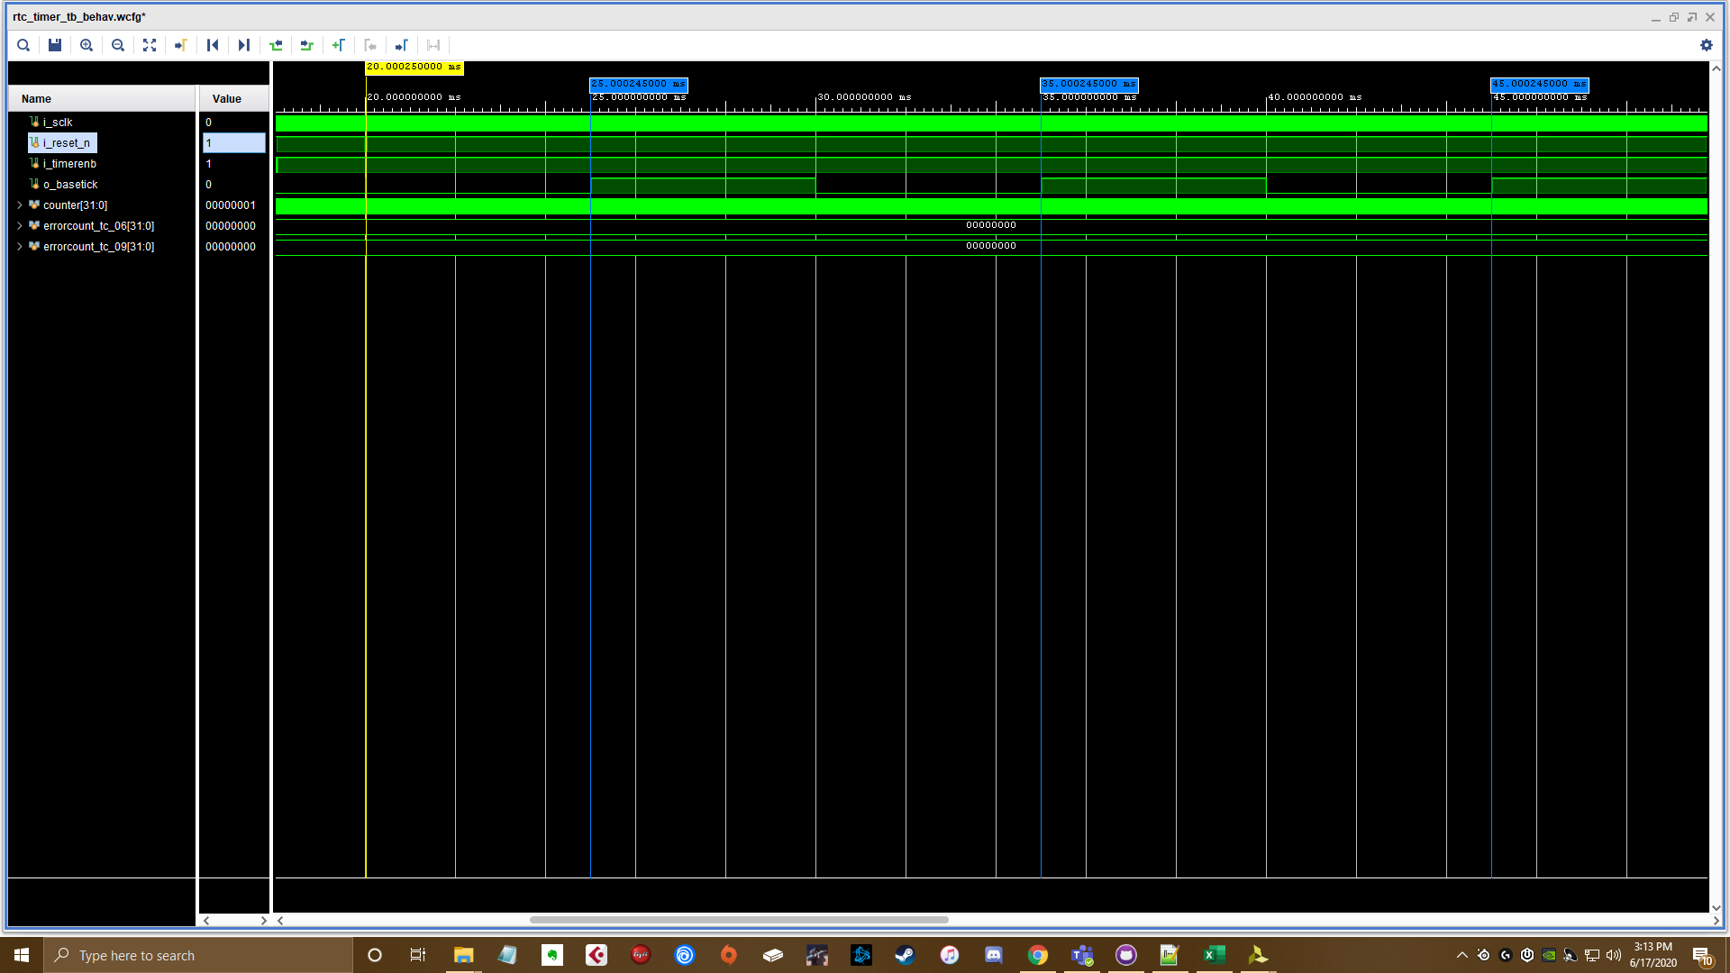

* Waveform shows 10ms period output on ‘o_basetick’ after test case start time.